Bachelor Of Engineering In Information Technology

2nd Year 1st Semester, gExamination, 2021-2022

Subject Name: (IT/PC/B/T/213) Database Management Systems

**CO-Wise Assignment**

**CO1:**

1. State List the advantages of DBMS?
2. List the database Applications?
3. Define instances and schemas of database?
4. Discuss Data Independence?
5. Compare and Contrast file Systems with database systems?
6. Define Data Abstraction and discuss levels of Abstraction?
7. Describe the Structure of DBMS?
8. Describe the concept of Referential Integrity.

**CO2:**

1. 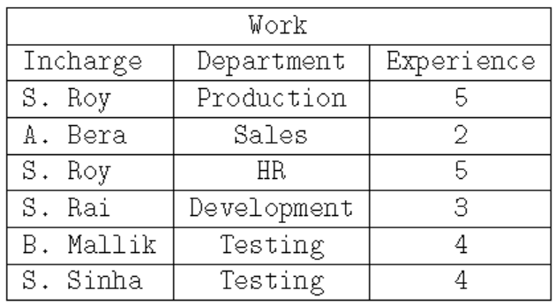Identify all functional dependencies that can hold on to the given instance Work?
2. Consider the following instance of the relational schema R(X, Y, Z):

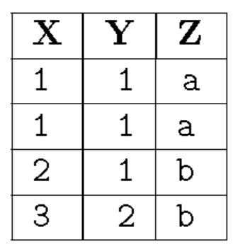

Justify that the following functional dependencies hold or not.(Mentions all steps)

i) X🡪Y

ii)Y🡪Z

1. Consider the following relational schema:

Student (Reg_No, Name, Address, Phone, Class_ID)

The following functional dependencies hold:

FD1: Reg_No 🡪 {Name, Address}

FD2: Address, Phone 🡪 Class_ID

FD3: Name 🡪 Phone

FD4: Class_ID 🡪 Reg_No

Identify all candidate key(s) for the above relation.

What is the highest normal form of R?

1. Explain Update Anomaly and Insertion Anomaly in details with a proper example.
2. Explain about Loss less-join dependency?
3. Demonstrate transitive dependency? Give an example?
4. Define BCNF?
5. Discuss Normalization?
6. Define functional dependencies. How are primary keys related to FD’s?

**CO3:**

1. Consider the following instance of the two relations given below:

PRODUCT (NAME, COUNT, SHOPID) and QUANTITY (COUNT, SHOPID)

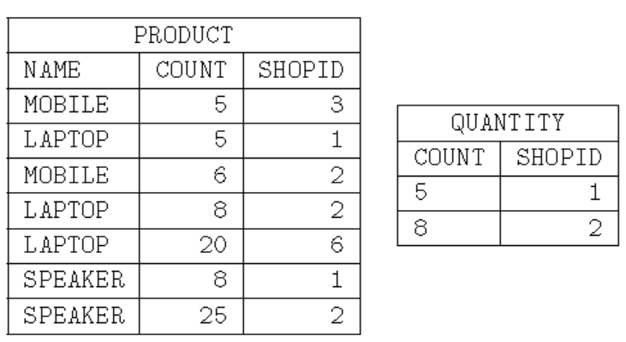

What product name(s) will be displayed by the operation PRODUCT ÷ QUANTITY?

1. Consider two relation schemas given below:

HOSPITAL (HOSPITALID, NAME, LOCATION) and DOCTORS (DOCTORNAME, HOSPITALID)

Write down the Relational Algebra expression equivalent to the following statement given below.

i) “Names of all doctors available in NRS hospital”

ii) “Name and location of all hospital in which Dr. T Sarkar is attached”.

1. Discuss about RENAME and PROJECT operation in Relational Algebra?
2. Illustrate different set operations in Relational algebra with an example?
3. Define Join? Explain different types of joins?
4. Discuss different types of aggregate operators with examples in SQL?
5. Illustrate Group by and Having clauses with examples?
6. Discuss correlated nested queries? Write a query to find the names of sailors who have reserved a red boat? Write a query to find the names of sailors who have not reserved a red boat?

**CO4:**

1. Why is indexing required for a database?

2. Justify this statement “In a secondary index file, all the search key values must be presented”.

3. Let us consider the following statistics for searching for a condition in a given relation.

Number of blocks containing record of the relation (b) = 500

Time to transfer one block (tb) = 0.3 milliseconds

Time for one seek (ts) = 4 milliseconds

Find out the cost of selection query on a key attribute using linear search file scan.

4. Suppose a file is organized using a B+ tree of order 4. The search-keys are inserted in the following order: 1, 5, 10, 24, 30, 3, 8, 13, 27, 35, 15, 17, 19.

Draw the B+ tree and justify this statement “The Key 24 will be in root node”.

5. What are the indexed data structures? Explain in detail.

6. Compare I/O costs for all File Organizations?

7. Explain about Hash based Indexing and Tree based Indexing?

8. Explain insertion and deletion operation in B+ trees?

9. Explain B+ trees? Discuss about this Dynamic Index Structure?

10. Discuss about data on External storage?

11. Explain insertion and search operation in B+ trees?

12. Consider the following B+ tree of order 5:



What will be the correct B+ tree after insertion of key 60?

**CO5:**

1. Consider a simple check pointing protocol and the following set of operations in the log where immediate database modification scheme is used.

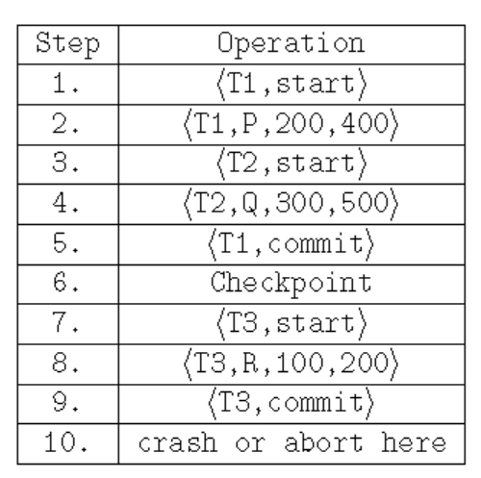

If a crash occurs just after step 8 and the recovery of the system is successfully completed, what will be in the undo list and redo list?

2. Let us consider the following statistics for two relations Customers and Orders:

* Number of records of Customers: nCustomers = 300.
* Number of blocks of : bCustomers = 30.
* Number of records of Orders: nOrders = 100.
* Number of blocks of Orders: bOrders = 10.

Let us consider a natural join of Orders ⋈ Customers.

Find out the required number of block transfers in the worst case (enough memory only to hold one block of each relation) and assume Orders as the outer relation.

3. Consider the following schedule S involving three transactions T1, T2, T3.

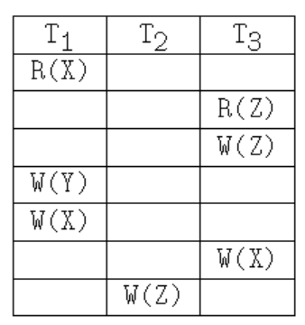

R(X) denotes read operation on data item X by transaction Ti.

W(Y) denotes write operation on data item Y by transaction Ti.

Identify the number of conflict serializable schedule of the above schedule S.

4. Consider the following schedule S.

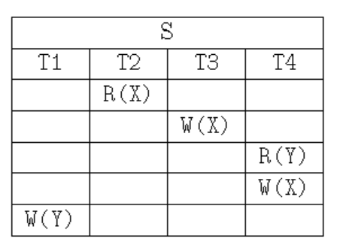

R(X) denotes read operation on data item X by Transaction Ti

W(Y) denote write operation on data item Y by Transaction Ti

Find out the correct order of execution of the following schedule.

5. Explain in detail about Serializability.

6. Explain ACID properties and illustrate them through examples?

7. Illustrate Concurrent execution of transaction with examples?

8. Discuss two phase locking protocol and strict two phase locking protocols?

9. Discuss deferred database modification and immediate database modification?

**CO6:**

1. Briefly explain distributed database systems

2. Compare Distributed Database, Decentralized Database and Data Warehouse.

3. Compare the Homogeneous and Heterogeneous Distributed Database.

4. Write down the advantages of Distributed databases over Centralized databases.

5. Write down the 5V’s (characteristics) of big data.

6. Explain in details Data warehousing.

7. Explain in details of data mining.